📘 AUTONOMY FOUNDATIONS — DOCUMENT v0.1
(Up to Foundation-B · Epistemic Dynamics)

1. Purpose of This Document
This document defines the foundational principles of autonomy derived from:
- real hardware experiments
- observed failure modes
- structural reasoning
The goal is not implementation, but correct behavior under uncertainty.

2. Definition of Autonomy
Autonomy is the capability of a system to decide whether to act or refuse action based on its internal assessment of knowledge and confidence.
Key clarification:
- Autonomy ≠ motion
- Autonomy ≠ intelligence
- Autonomy ≠ learning
Autonomy = governed behavior under uncertainty

3. Original Autonomy Loop (Insufficient)
Initial assumed loop:
Perceive → Decide → Act → Evaluate → Adapt
Hidden assumption (invalidated by experiment):
Perception always contains meaningful information.

4. Phase-2 Experimental Observation (Empirical Basis)
Setup
- Ultrasonic sensor
- Continuous logging
- Confidence decay model
Observed behavior
- Sensor returned invalid readings (distance = 0)
- Outcome = UNKNOWN
- Confidence decayed to zero
- System continued acting
Conclusion
Confidence decay alone does not inhibit action.
This behavior is unsafe and non-autonomous.

5. Introduction of Epistemic Validity
Definition
Epistemic Validity answers the question:
“Does the current perception contain usable knowledge about the world?”
This is knowledge existence, not knowledge correctness.

6. Epistemic State Variable
We define a new internal variable:
E ∈ { VALID, INVALID }
- VALID → perception contains usable information
- INVALID → perception contains no usable information

7. Formal Epistemic Gate Law (Law-1)
Law-1 (Epistemic Gate):
If Epistemic Validity is INVALID, the system must not act, regardless of confidence.
Formally:
E = INVALID ⇒ Action = REFUSE
This law overrides all decision and confidence mechanisms.

8. Corrected Autonomy Loop
Perceive
↓
Epistemic Check (E)
↓
[ if E = INVALID → REFUSE ACTION ]
↓
Decide
↓
Act
↓
Evaluate
↓
Adapt

This loop prevents action without knowledge.
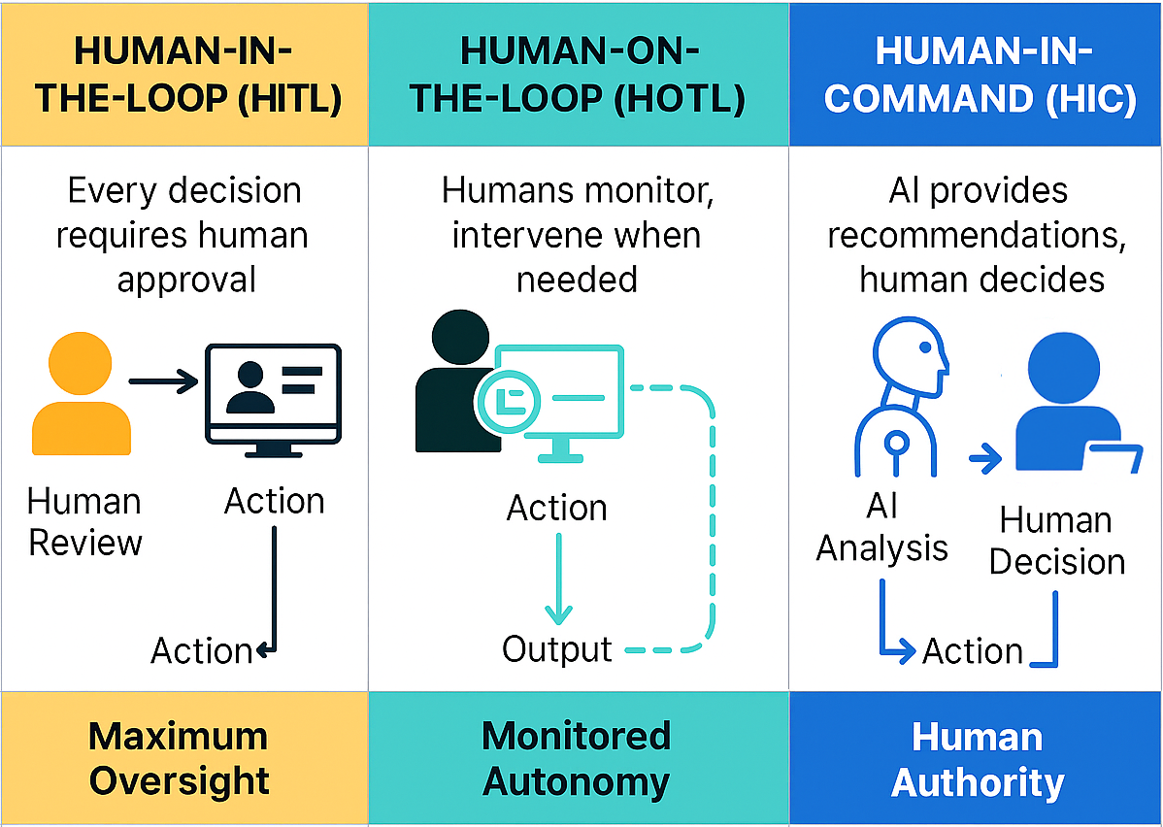
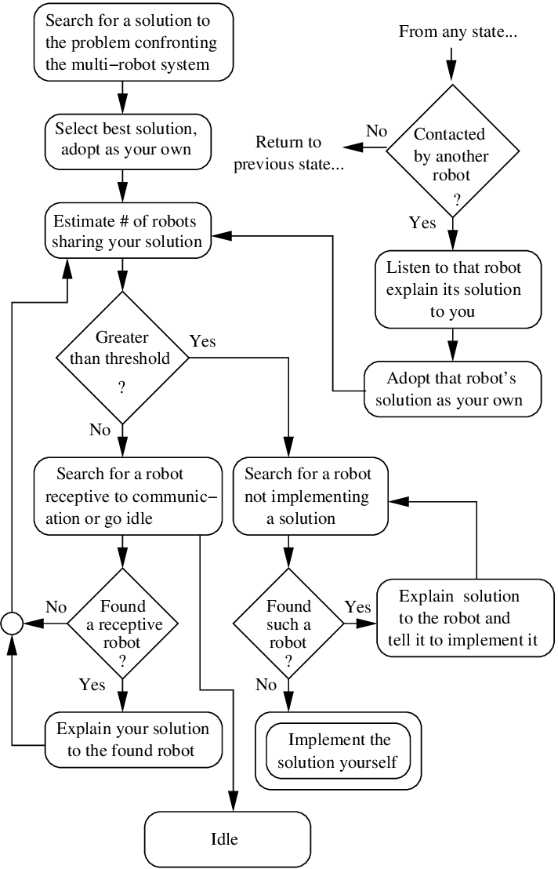

9. Relationship Between Epistemic Validity and Confidence
Concept | Meaning | Role
Epistemic Validity (E) | Knowledge exists? | Permission
Confidence (C) | Strength of belief | Modulation
Rules:
- Epistemic Validity gates action
- Confidence modulates action
Confidence cannot override epistemic invalidity.

10. Epistemic Dynamics (Foundation-B · Step 1)
Epistemic Validity evolves over time.
States
E ∈ { VALID, INVALID }
Transition Rules
VALID → INVALID
Triggered by:
- invalid sensor reading
- timeout
- physically impossible values
- strong inconsistency
Knowledge loss is immediate and conservative.

INVALID → VALID
Triggered only when:
- perception becomes meaningful
- stability is observed
- validity persists over time
Knowledge must be earned, not assumed.

11. Epistemic Asymmetry Law (Law-2)
Law-2 (Epistemic Asymmetry):
Losing knowledge requires less evidence than gaining it.
This asymmetry reflects real-world sensing and prevents false recovery.

12. Behavioral Consequences
Epistemic State | Confidence | Behavior
INVALID | any | REFUSE
VALID (fresh) | low | CAUTIOUS
VALID (stable) | high | ACT
Autonomy emerges from controlled hesitation, not impulsive action.

13. Key Insights Achieved So Far
- Acting without knowledge is the primary failure mode of autonomous systems
- Confidence alone is insufficient for safe behavior
- Epistemic validity must gate decision-making
- Knowledge recovery must be asymmetric and slow
- True autonomy includes the ability to refuse action

14. Current Status
✔ Foundation-A completed
✔ Phase-2 experimental validation completed
✔ Epistemic variable introduced
✔ Structural autonomy laws defined
✔ Epistemic dynamics defined
🚧 Quantification (math, timing, thresholds) not yet started

15. Closing Statement
Autonomy is not the ability to act.
It is the discipline to refuse action when knowledge is absent.
This document defines the constitutional layer of the system.
All future code, math, hardware, and AI must obey it.

